## **Exercise 1-1: Identify stakeholders for an integration solutions scenario**

**Identify the goals of the Phase 1 project.**

Migrate all existing customers into salesforce

Bidirectional synchronisation of customer data between Legacy System and Salesforce

Implement the phase 1 synchronization project using API Led Connectivity

# 

# **Identify the Phase 1 project's stakeholders**

Identify the major stakeholders involved in the initial Phase 1 initiative, their roles, responsibilities, and ownership.

|  |  |  |  |
| --- | --- | --- | --- |
| **Stakeholder** | **Role** | **Responsibilities** | **Primary concern** |
| Marketing Campaign Manager  Travel Agents | User | Make sure they are able to give accurate functional and nonfunctional requirements  Make sure the systems are working fine when its delivered | Requirements |
| Director of Integration Architecture | Technical Enabler | Technical Enabler | Eliminate point-to-point integration.  Scalable & reusable integration |
| Central IT Head | IT | Infrastructure Provisioning | Uninterrupted operations of existing system |
| GetAways Architect | Architect | Responsible for designing Mule Interfaces & solution required for the use cases | Mule Integration Architecture |
| Tester | Tester | Make sure the solution delivered is working as per requirements | End to End Testing |
| Operation Team | DevOps | Responsible for CI/CD and operational support of interfaces | BAU |

# 

# **Exercise 1-2: Document user stories for a case study**

**Document user stories for the phase 1 project**

1. As a Marketing Campaign Manager, i want to load all customers from my legacy customer database in to salesforce as a one time manual activity so that I can run vacation travel bundle marketing campaigns with the customers in salesforce.
2. As a Marketing Campaign Manager, I want to load new customers created/updated/deleted in legacy customer database into salesforce near real time so that I can run vacation travel bundle marketing campaigns for all the new customers.
3. As a Travel Agent, I want to load new customers created/updated/deleted in salesforce into legacy customer database near real time so that I can run marketing campaign in legacy system.
4. As a Operation Team user, I want to see all failures in external logging system so that I can take corrective action against each of the failures .
5. As a Information Security Team User, I want to secure apis by providing client_id and client_secret in all apis so that I am aware of all the consumers of the system APIs.
6. As a Information Security Team user, I want to secure apis by configuring two-way ssl in all APIs so that I can prevent man in the middle attack .
7. As a operational user, I want to see a daily report of how many new customers are created and updated in both systems so that I can identify the integration is working fine

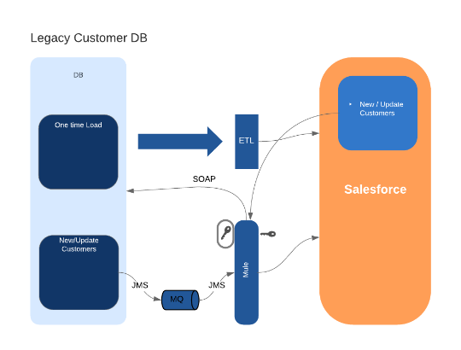

**Identify and discuss functional requirements for a use case**

|  |  |  |
| --- | --- | --- |
|  | **Requirement** | **Comments** |
| F1 | Onetime migration of all existing customers into salesforce from Legacy System | ETL |
| F2 | 2 way data -sync between CRM and Legacy ES |  |
| F3 | Reconciliation report |  |
|  |  |  |

**Identify and discuss non-functional requirements for a use case**

|  |  |  |
| --- | --- | --- |
|  | **Requirement** | **Comments** |
| NF1 | One time load must not have a high  performance impact on legacy db | Throttle Legacy System using API Policy |
| NF2 | All events should be logged to external  logging system | Configuring external logging system |
| NF3 | Data in transit must be secure | Mutual HTTPS/TLS |
| NF4 | Secure APIs via client_id and client_secret |  |
| NF5 | Alert business users on transactional and system failures via email | Notifications |
| NF6 | Data at rest must be secure | Encryption |

# **Exercise 1-3: 4+ 1 view points**

As an integration user, I want to load new customers created/updated/deleted in legacy customer database into salesforce near real time so that I can run vacation travel bundle marketing campaigns for all the new customers.

Logical View

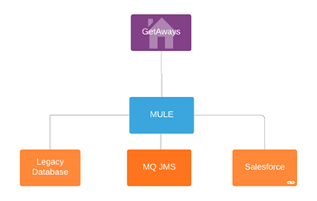

Process View

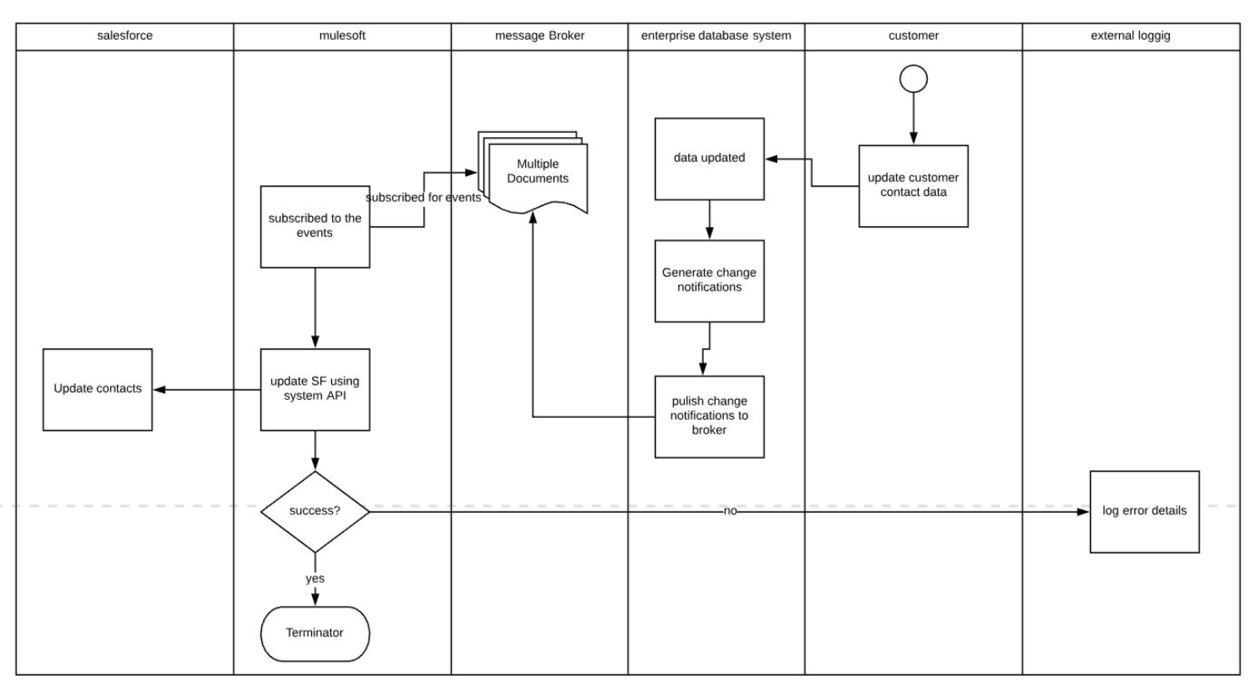

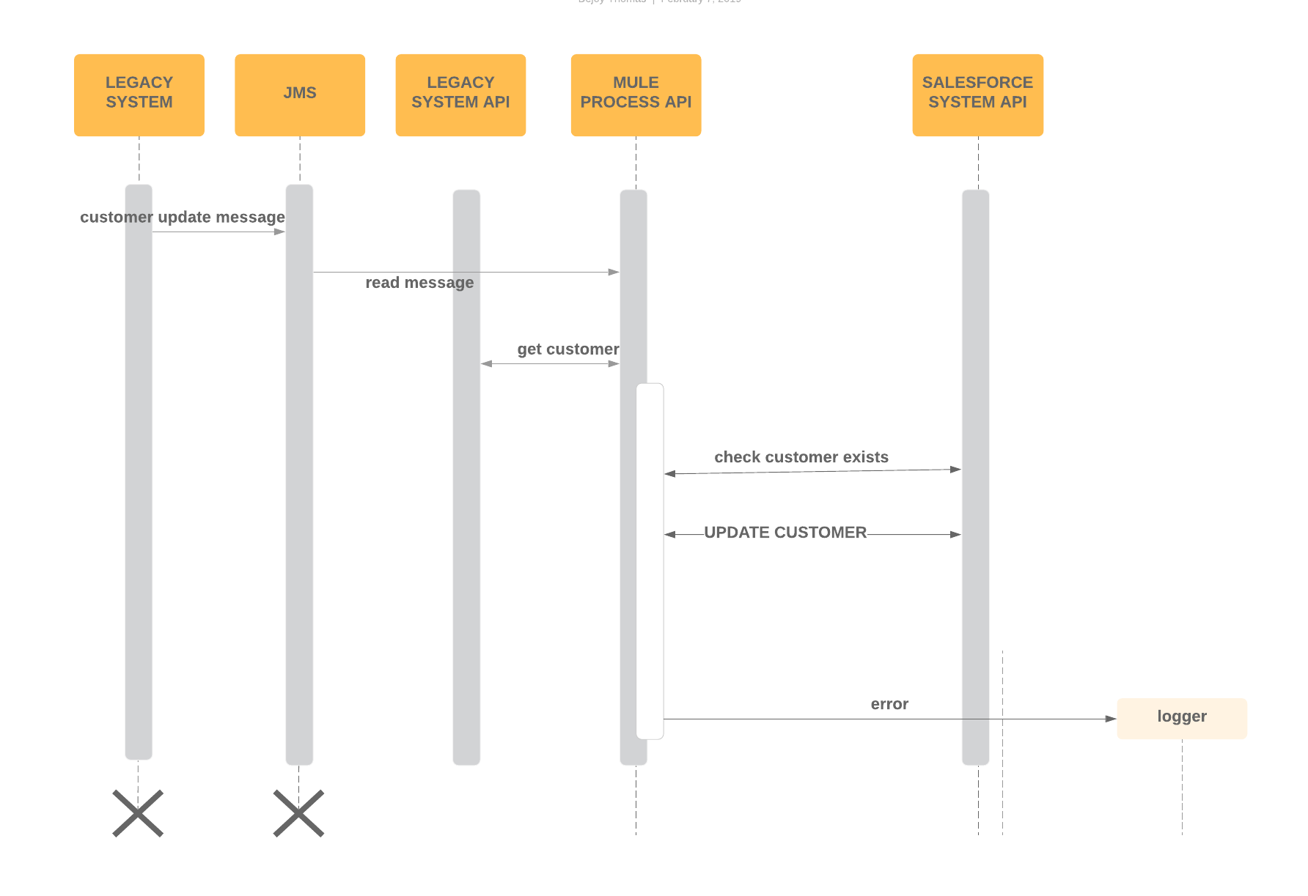

Development View

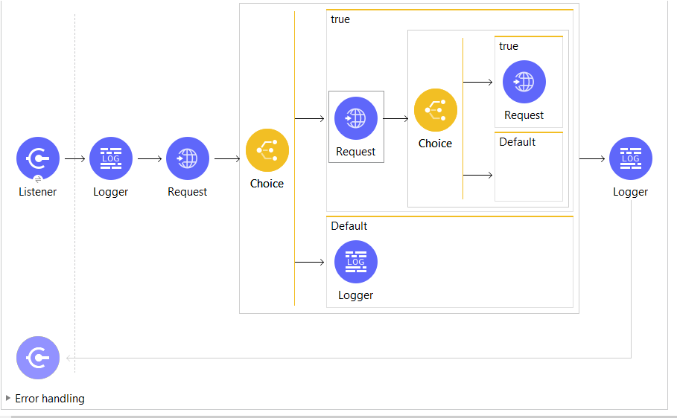

Physical View

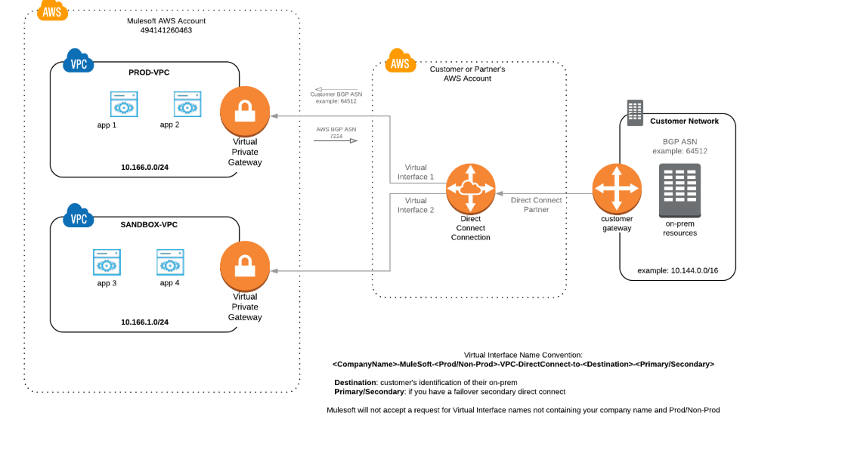

# **Exercise 2-2: Align Anypoint Platform components and capabilities with a use case**

**Identify functional requirements and map anypoint components associated**

|  |  |  |
| --- | --- | --- |
|  | **Requirement** | **Anypoint Components** |
| **F1** | **Onetime migration of all existing customers into salesforce from Legacy System** | **ETL Tool** |
| **F2** | **Synchronize any changes on existing and new customers from salesforce to Legacy system and vice versa** | **Anypoint Studio, Runtime Manager, Connectors, API Designer,** |
| **F3** | **Reconciliation report** | **Anypoint Studio, Runtime Manager, Connectors, API Designer,** |
|  |  |  |
|  |  |  |

**Identify non-functional requirements and map anypoint components associated**

|  |  |  |
| --- | --- | --- |
|  | **Requirement** | **Anypoint Components** |
| **NF1** | **Throttle Legacy System using API Policy** | **API Manager** |
| **NF2** | **External Logging** | **Log4j Appender** |
| **NF3** | **Enable HTTPS** | **DLB, VPC** |
| **NF4** | **Secure APIs via client_id and client_secret** | **API Manager** |
| **NF5** | **Alert business users on transactional and system failures via email** | **Anypoint Monitoring, Alerts, Business Events & Insights** |